 | Here are three of my ‘Glyphs of Light’.  They will cast a vibration into your space to support you. Simply print them out and place them intentionally on your altar or workspace.
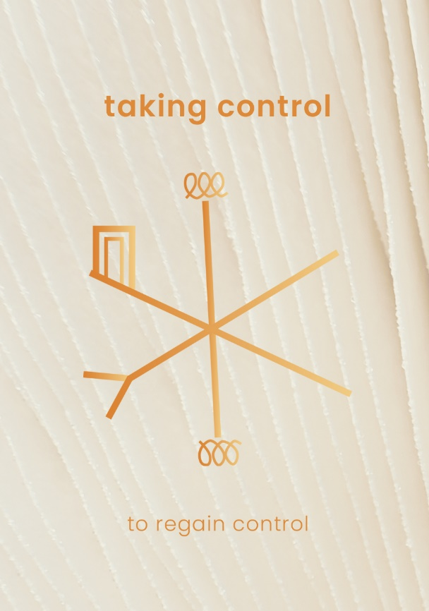 |  | This can be used either to regain control of a situation, or to encourage someone else to take control of a situation for you.  When using, call in the situation you want the Glyph to affect and think about it intentionally. Daydream about what life would look like with the outcome you want.
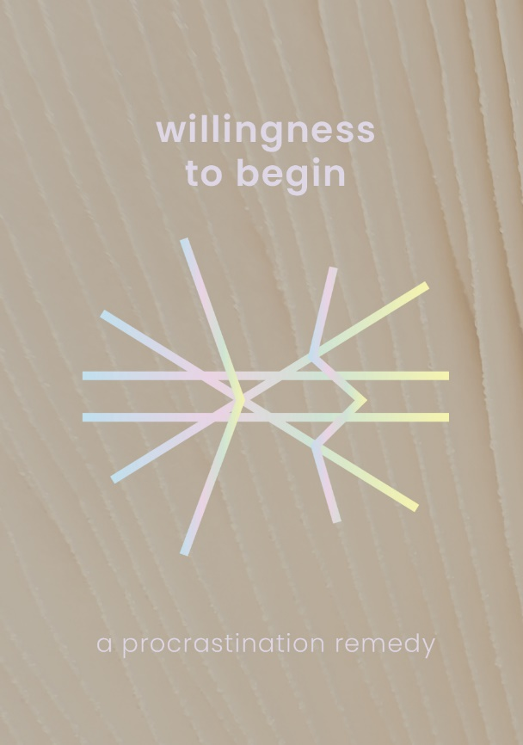 |  | To unblock procrastination of all kinds!
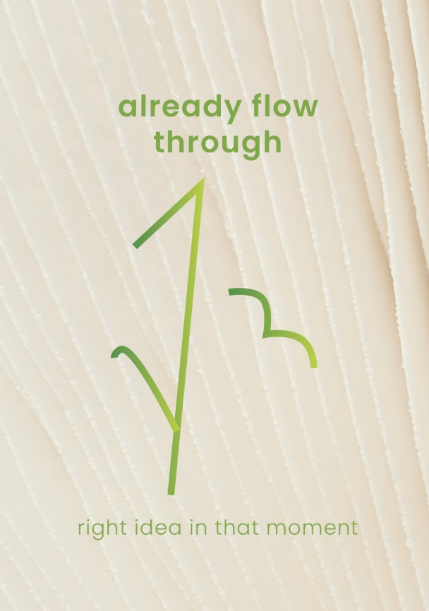 |  | This Glyph is to encourage ideas and thoughts to flow more easily. For the ‘right’ things to spring to mind exactly when you need them.  It is the perfect Glyph for planning projects or being creative.

www.shehasmagic.com
Any questions? Email Zoe: hello@shehasmagic.com

